# PaintShop

A brief description of what this project does and who it's for

## Description

PaintShop is basically website,based on MVC pattern, in which you can purchase and

also sell items and write comments.

There are two type of users:

* Admin- have the opportunity to track sales, add or remove new categories, products, second hand items,check all orders per users and give users admin rights and also edit personal information.

* User - can buy and sell items, edit personal information, edit their items for sale.

## Tech Stack

Front-End:

HTML

CSS

Bootstrap

JavaScript

Thymeleaf

Back-End:

Java

Spring Boot

Spring MVC

Spring Security

MySQL Database

Hibernate

JPA

## Running

Java (JRE) 14

Windows and MacOS X installers include JRE so just use them and don't think about internals.

On Linux you may need to install Java manually (usually by running sudo apt-get install openjdk-14-jdk or something similar).

If you don't use installer (on Windows or Mac OS X) you may need to download Java (JDK) from Oracle website.

MySQL Workbench 8.0.21

You can download MySQL Workbench from official website -https://dev.mysql.com/downloads/workbench/

## Building

Prerequisites:

Java (JDK) 14

Apache Maven 3+

MySQL Dialect 8

Internet access

Git client

Build

Before build the project you need follow a few steps:

In application properties file you can enter your personal database username and password:

spring.datasource.username=[DB USERNAME]

spring.datasource.password=[DB PASSWORD]

Application properties file is in src/main/resources/application.yml

Valid Profile Accounts:

Admin : email -> admin@gmail.com ; password -> 12345

User : email -> peshkata@gmail.com ; password -> 12345

## Database Diagram Screenshot

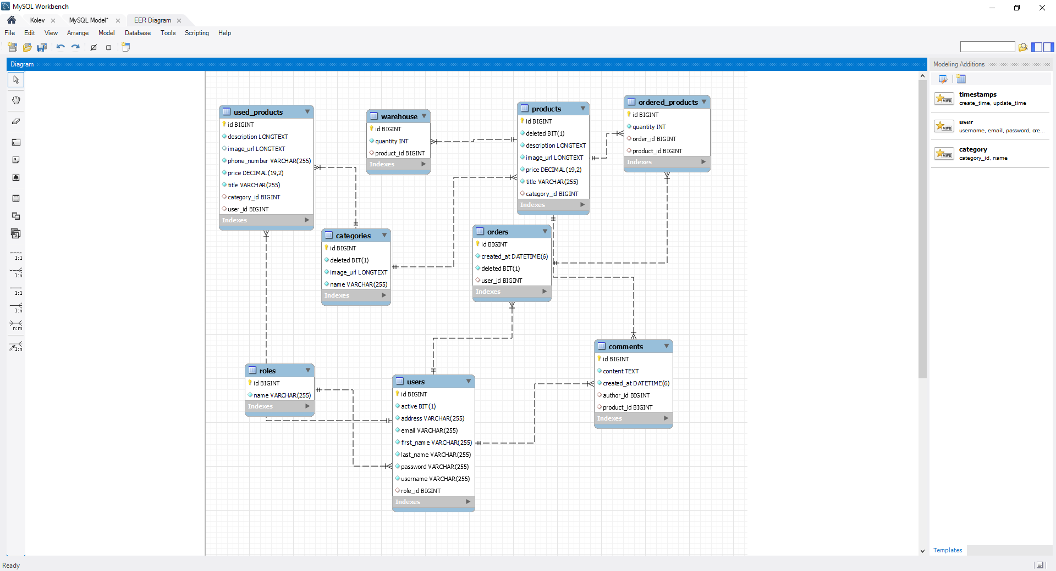

## Website Screenshot

Home page without logged user.

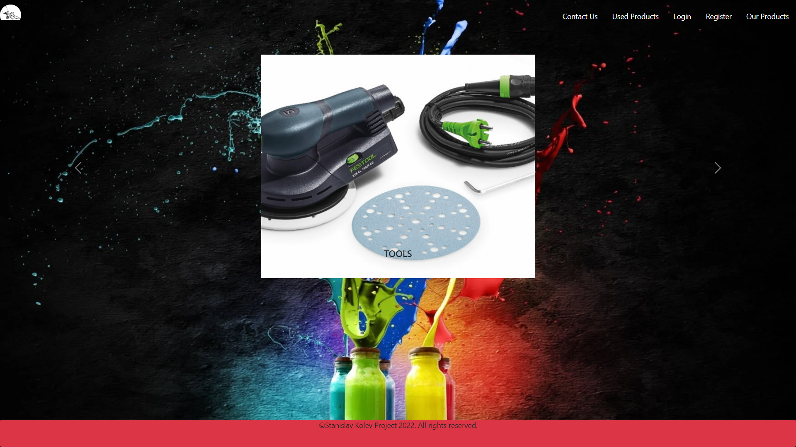

Home page with logged Admin.

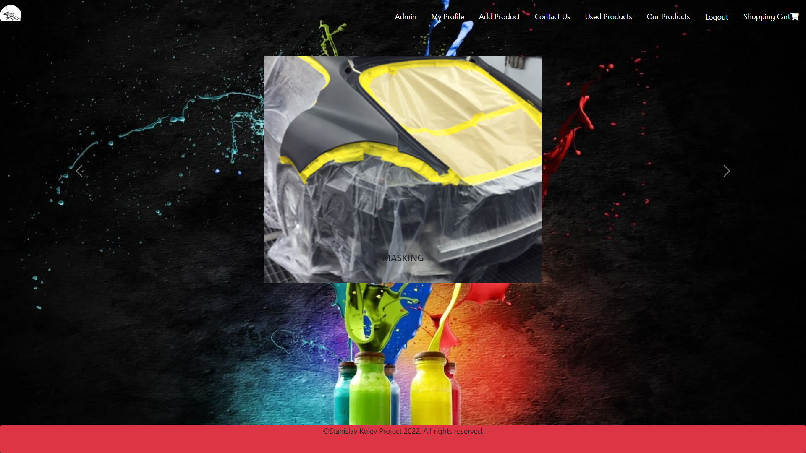

Home page with logged User.

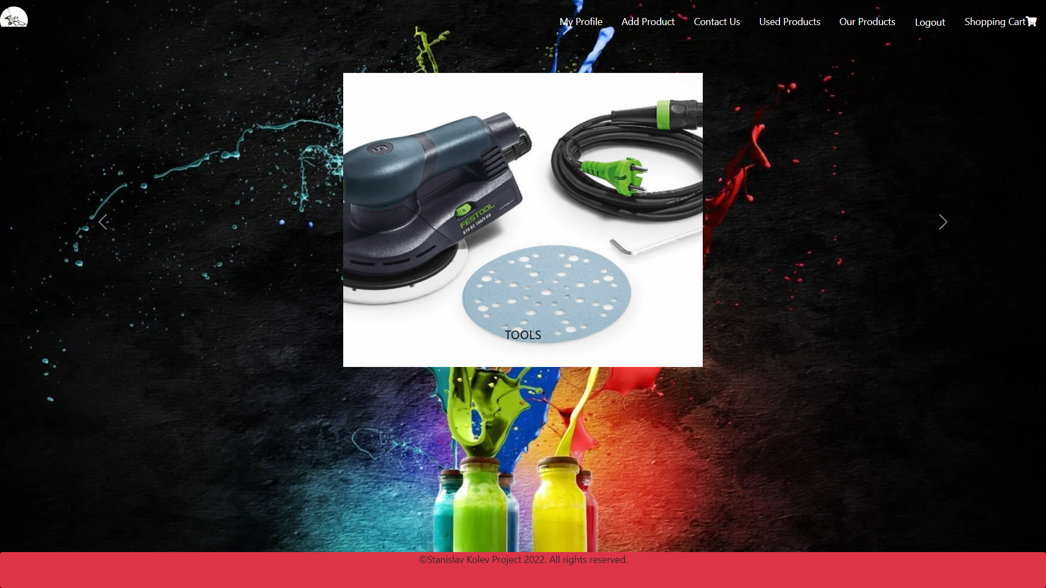

Login page

User uses email and password to log in.

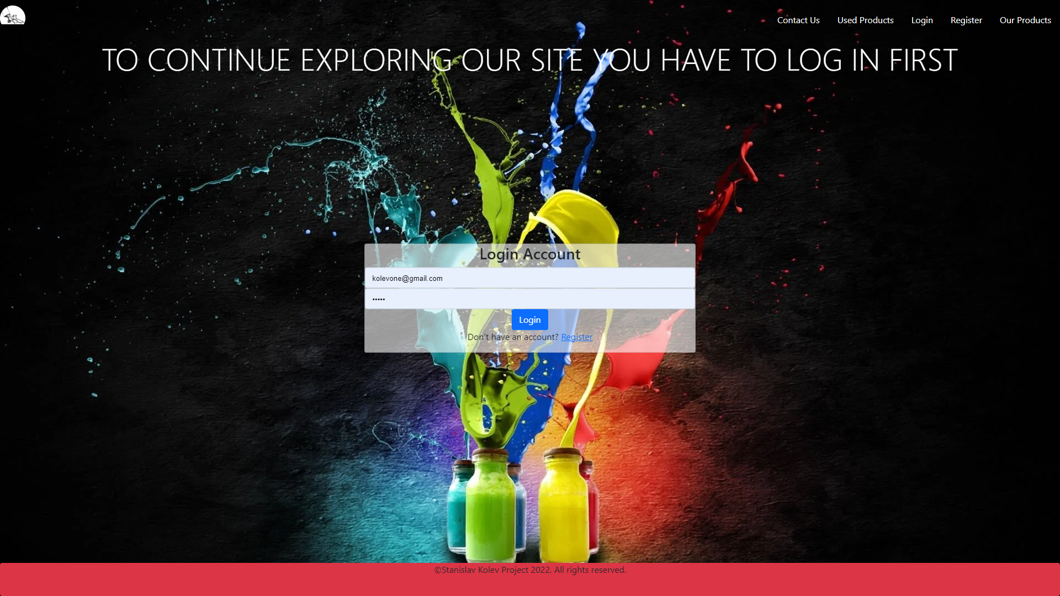

Register page

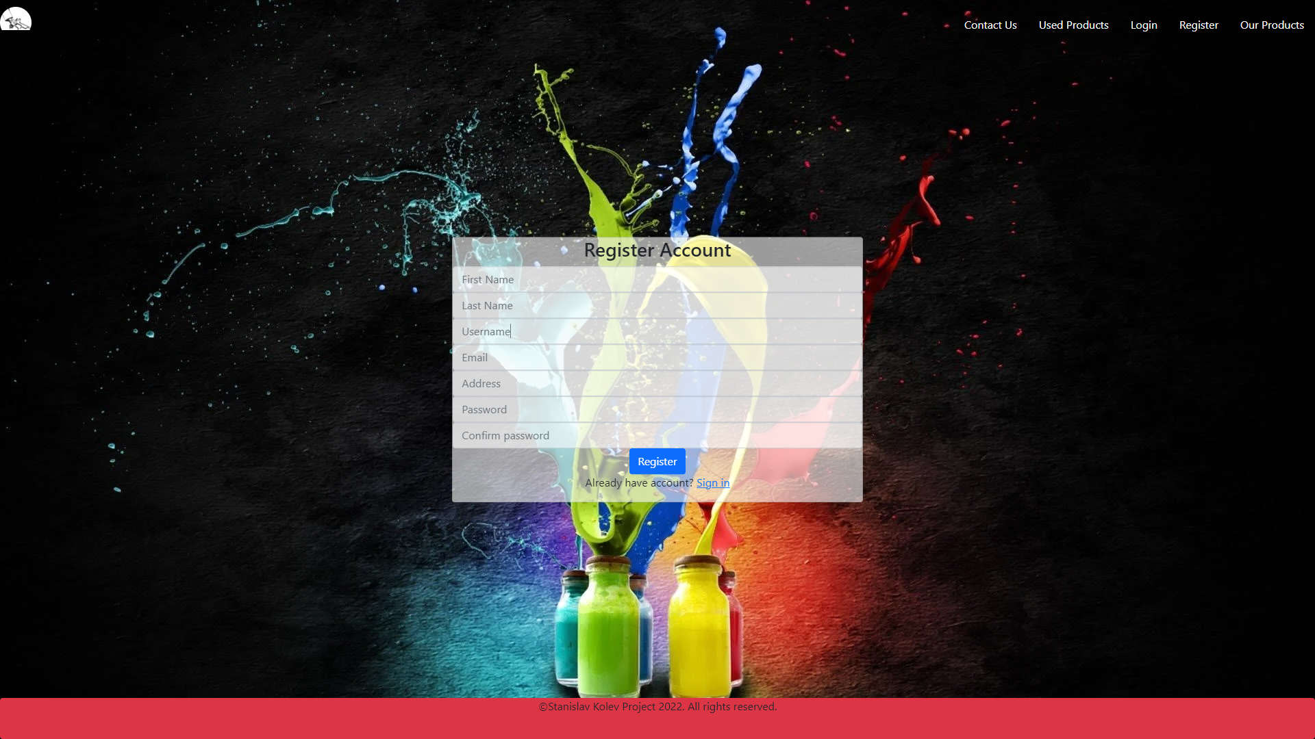

When invalid data is entered alert messages appear.

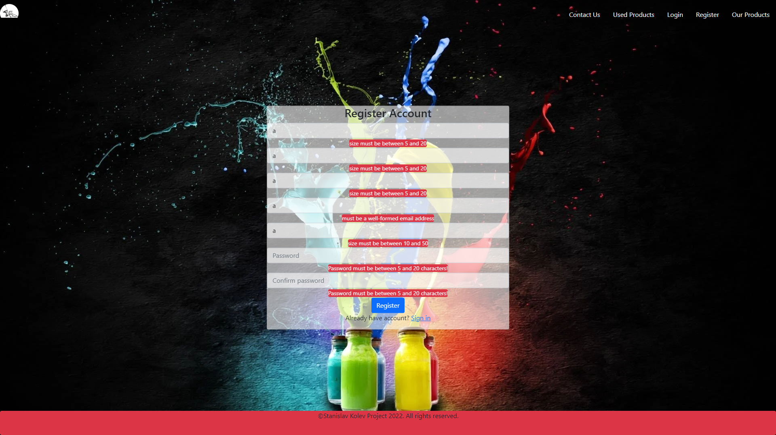

Used products page

The users can see all products published by other users.

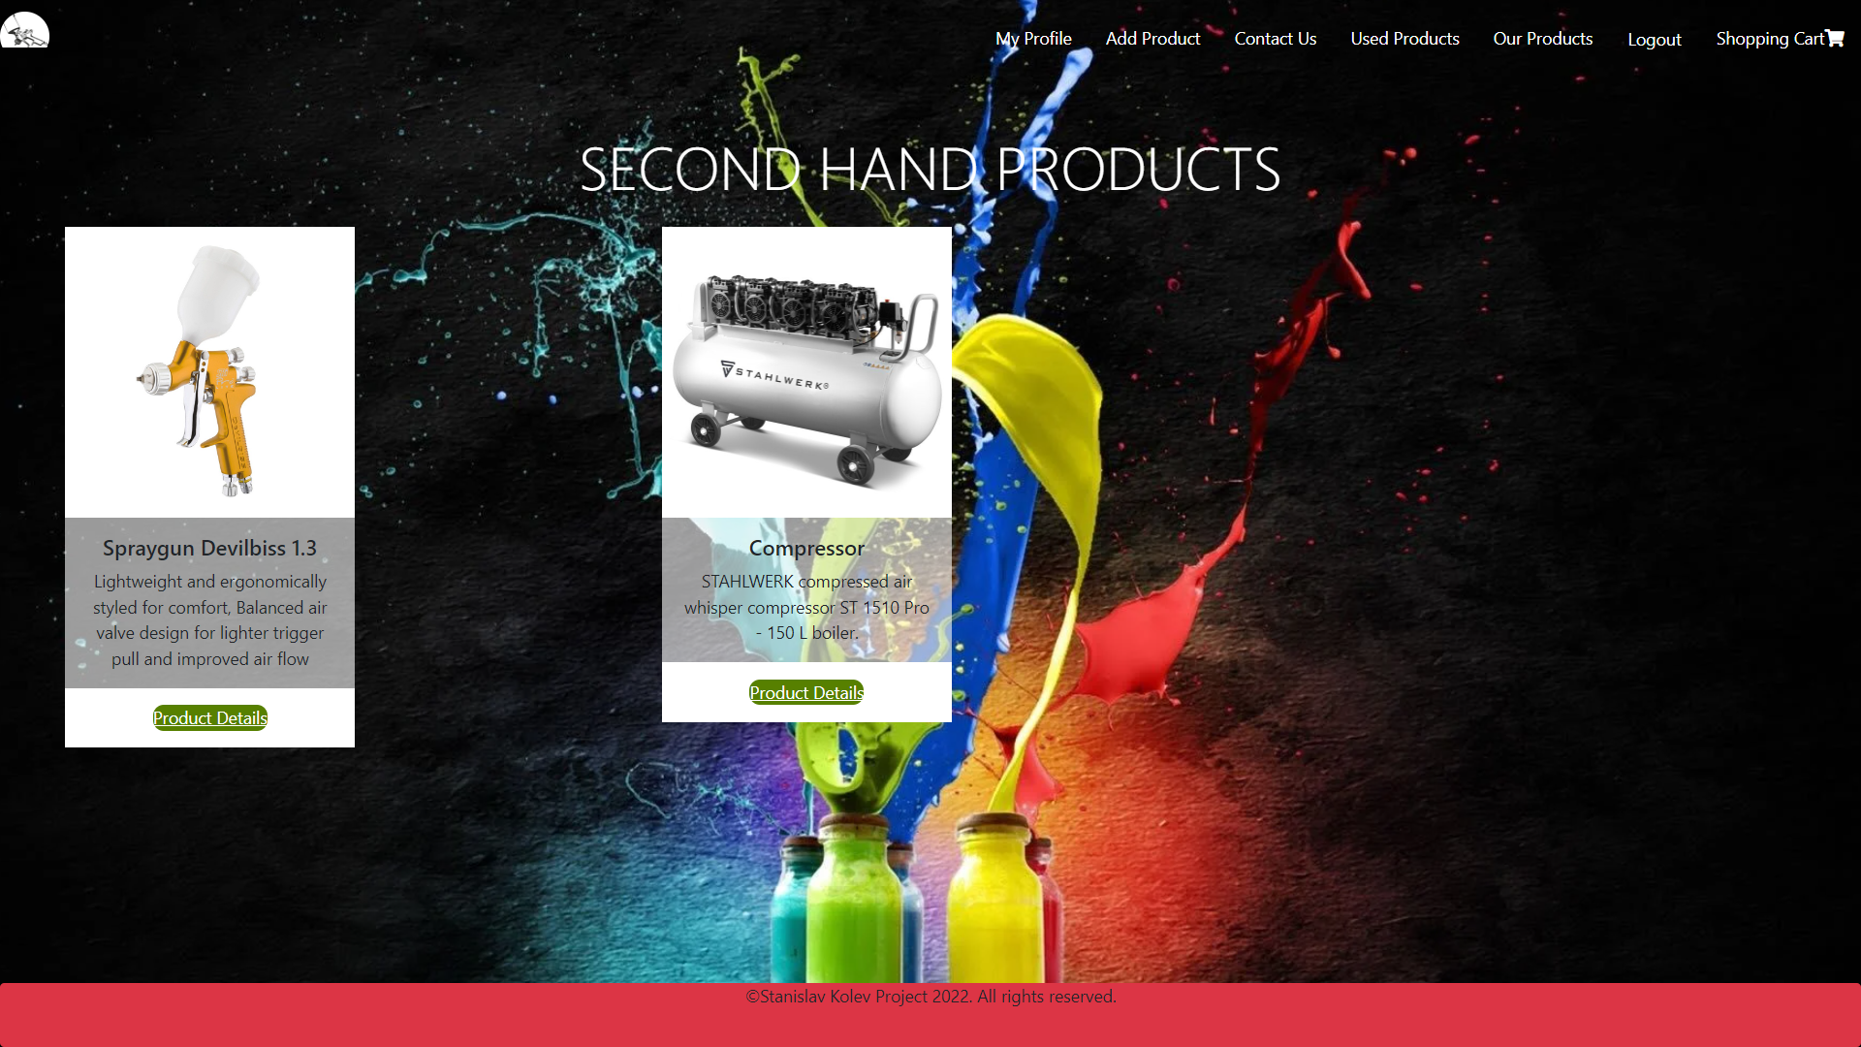

All products page

The users can see all new available items for sale.

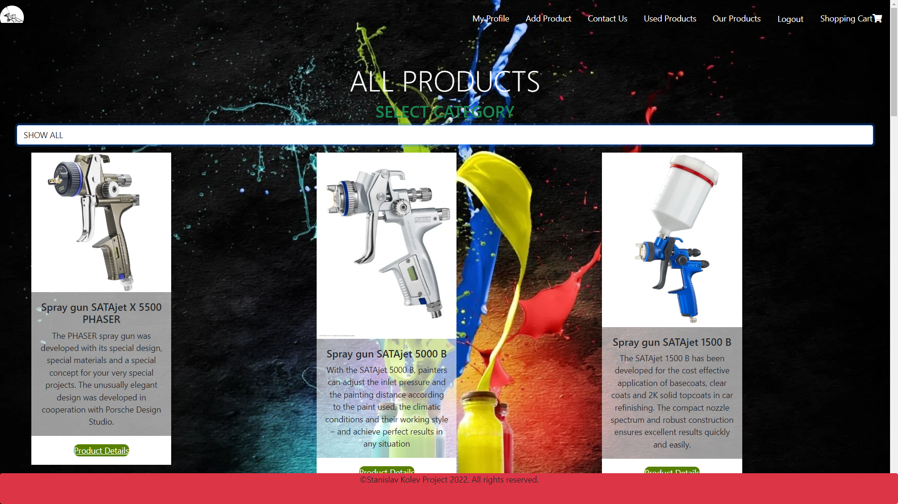

Products can be reduced by category.

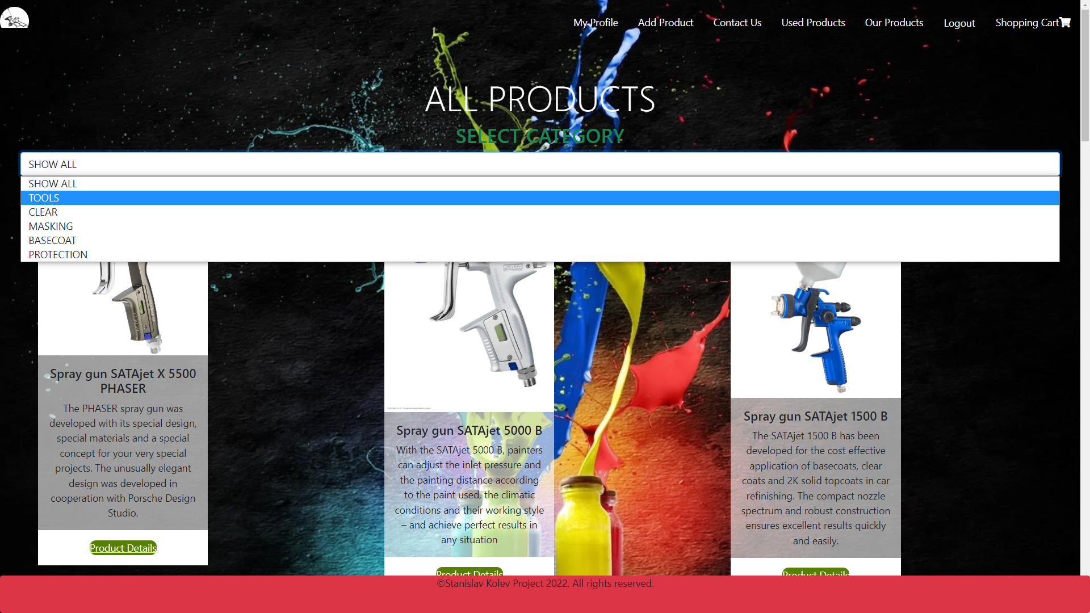

This is example of product details page.

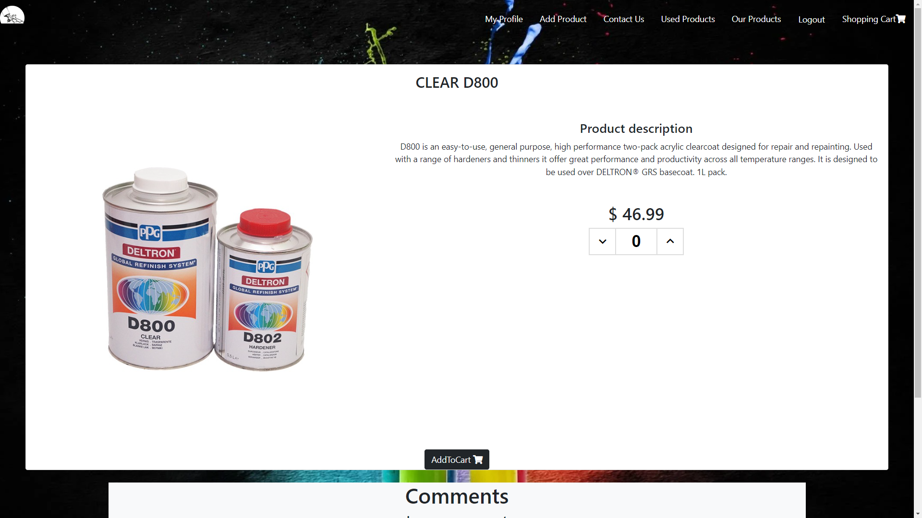

Users are able to add comments for every product.

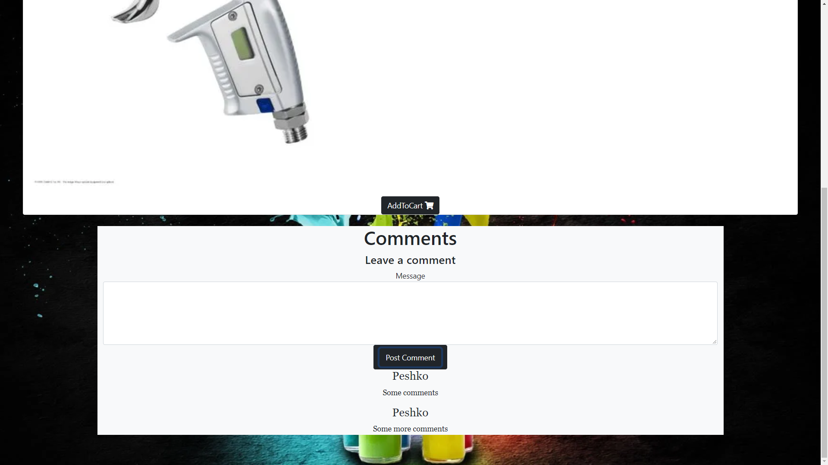

If users wants to buy more products than available alert message appears.

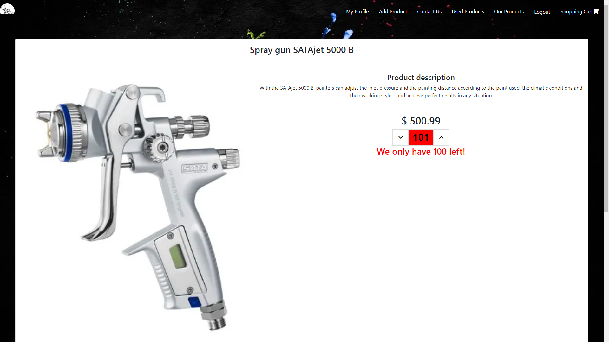

Contacts page

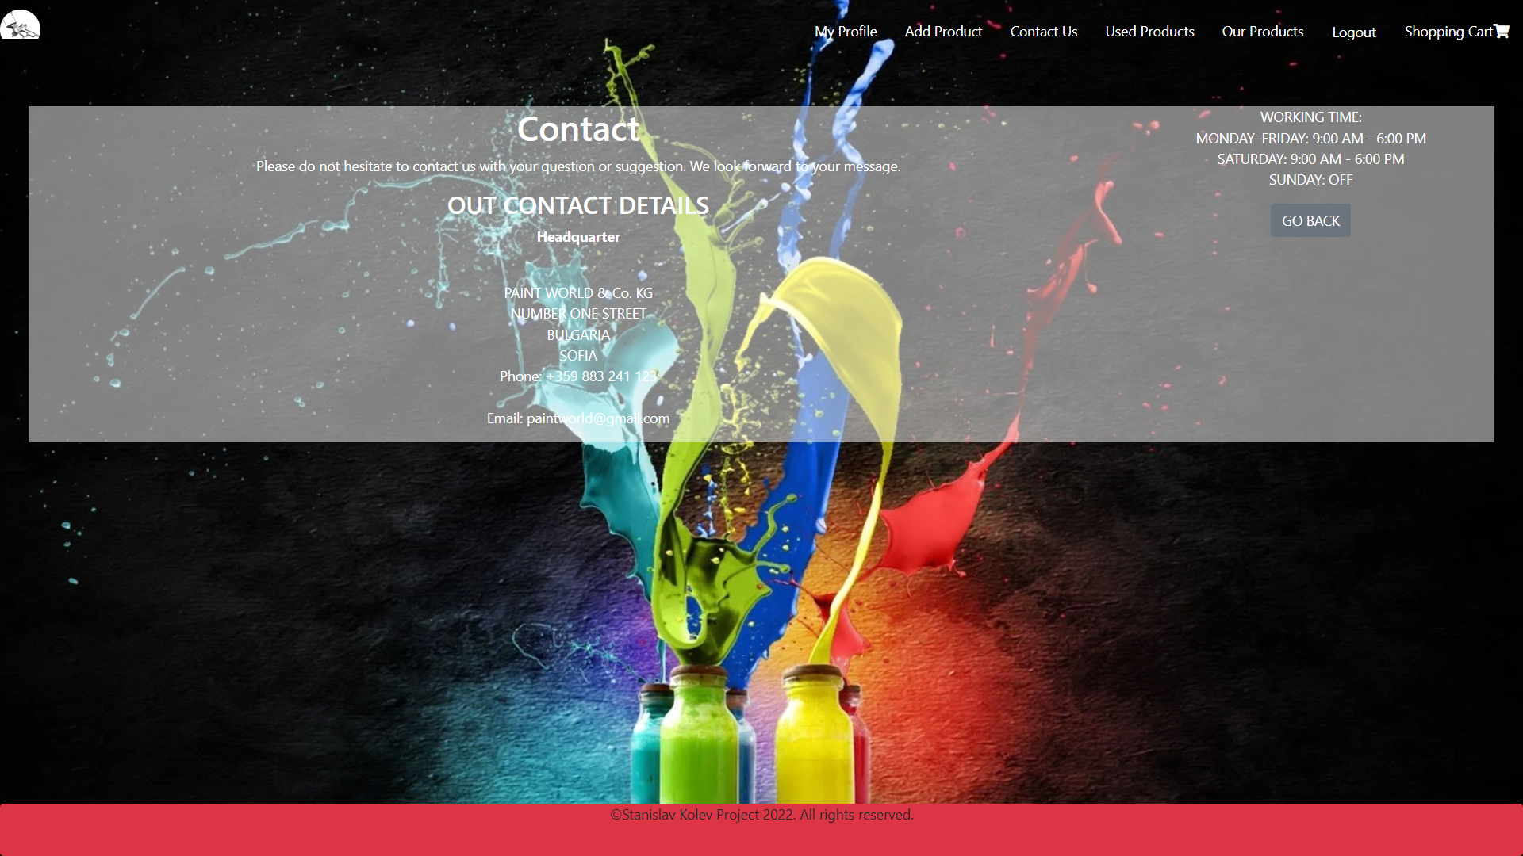

My profile page

User can edit personal information.

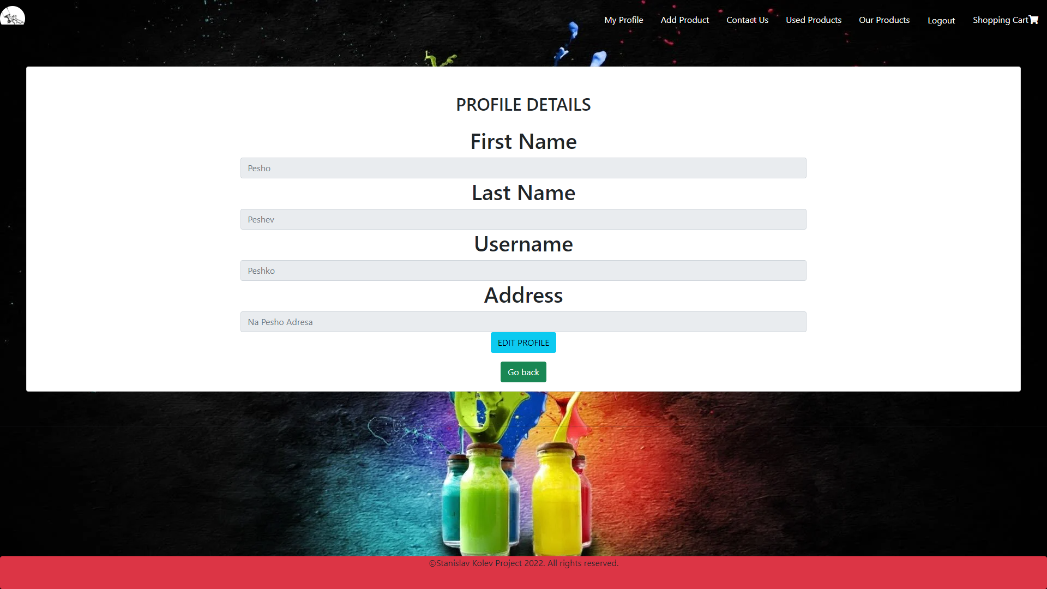

Shopping cart page( when cart is empty)

The user is asked to go the all products section.



Shopping cart page(when cart is not empty)

User can see the items, their number and can remove them from the shopping cart.

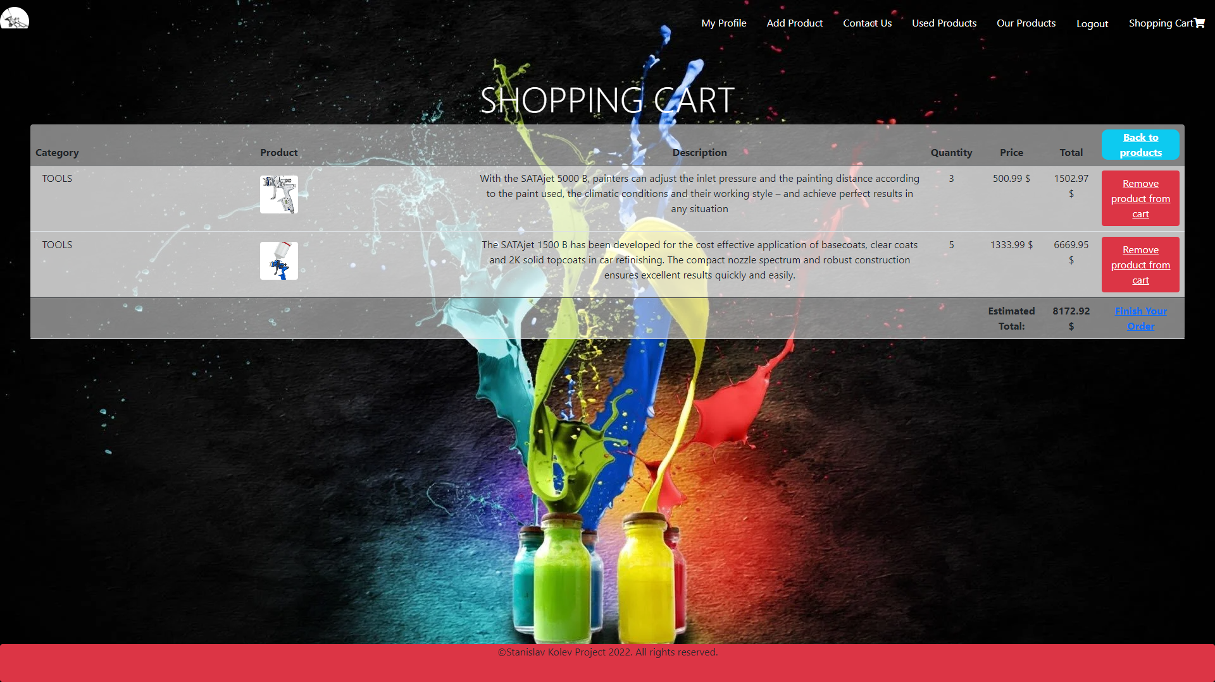

Also can edit the quantity by clicking on the photo of each product.

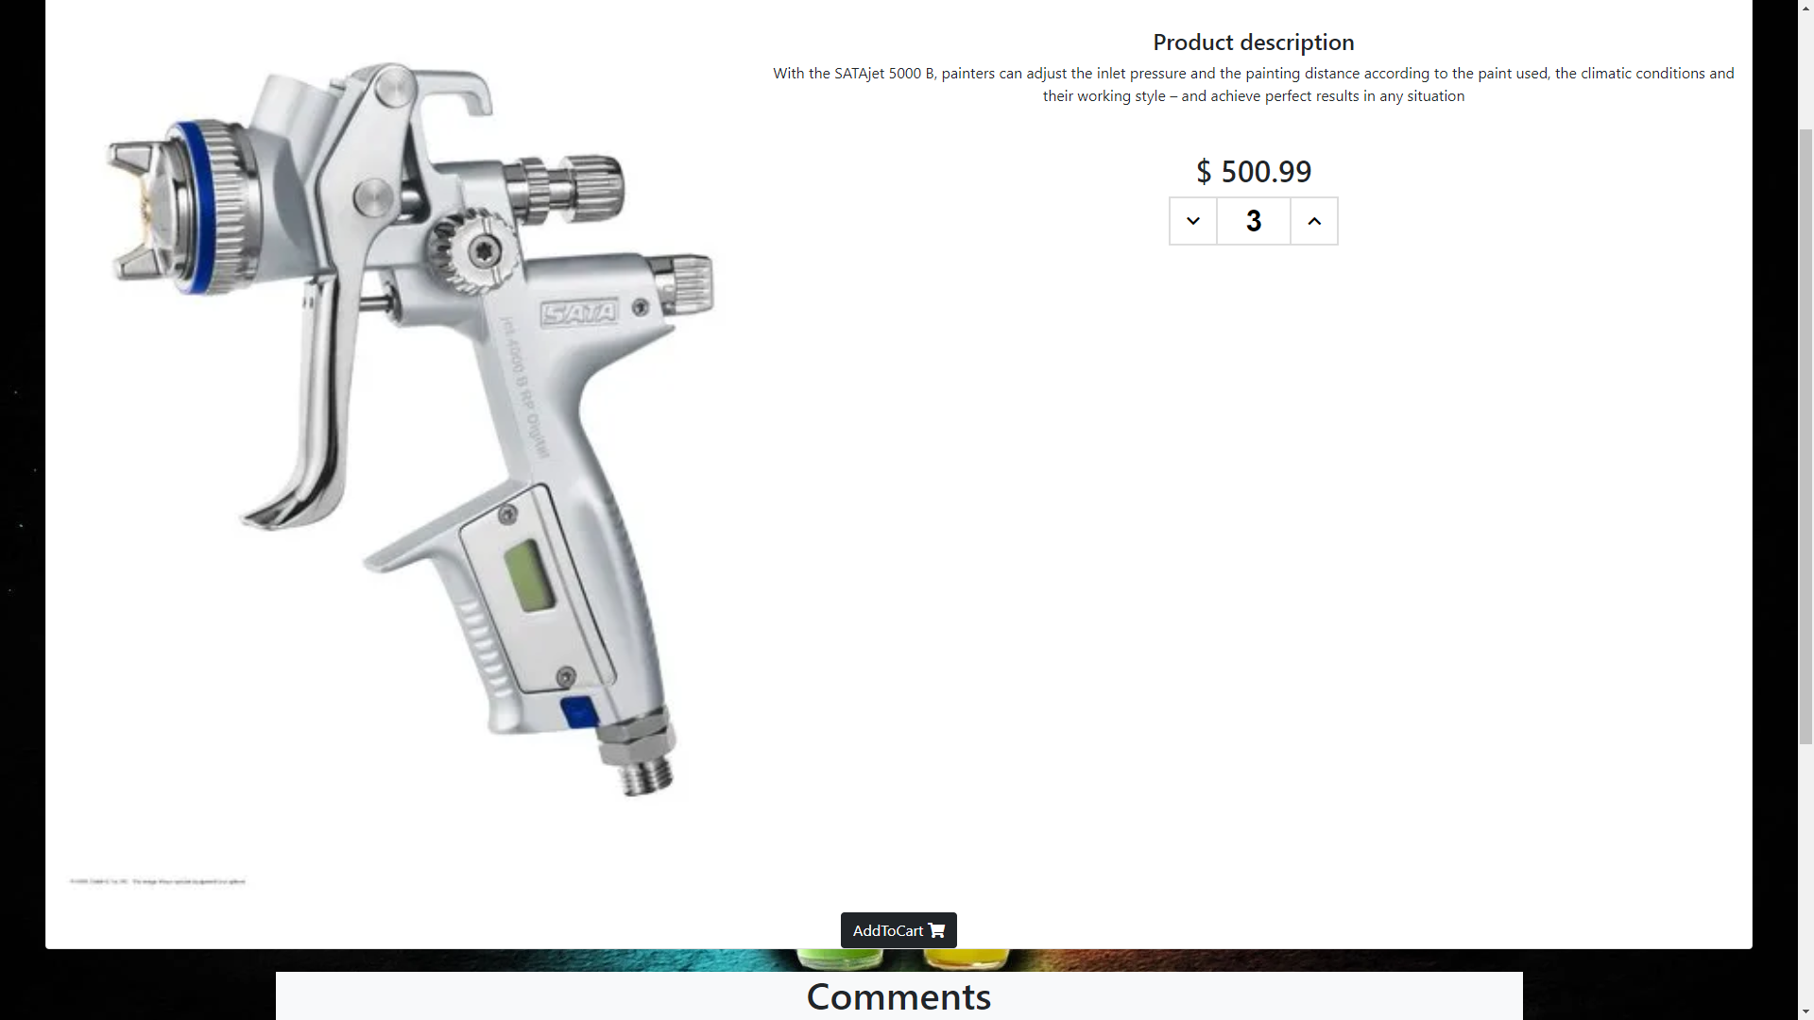

Add product page

User can add new product for sale. Image url is not required.

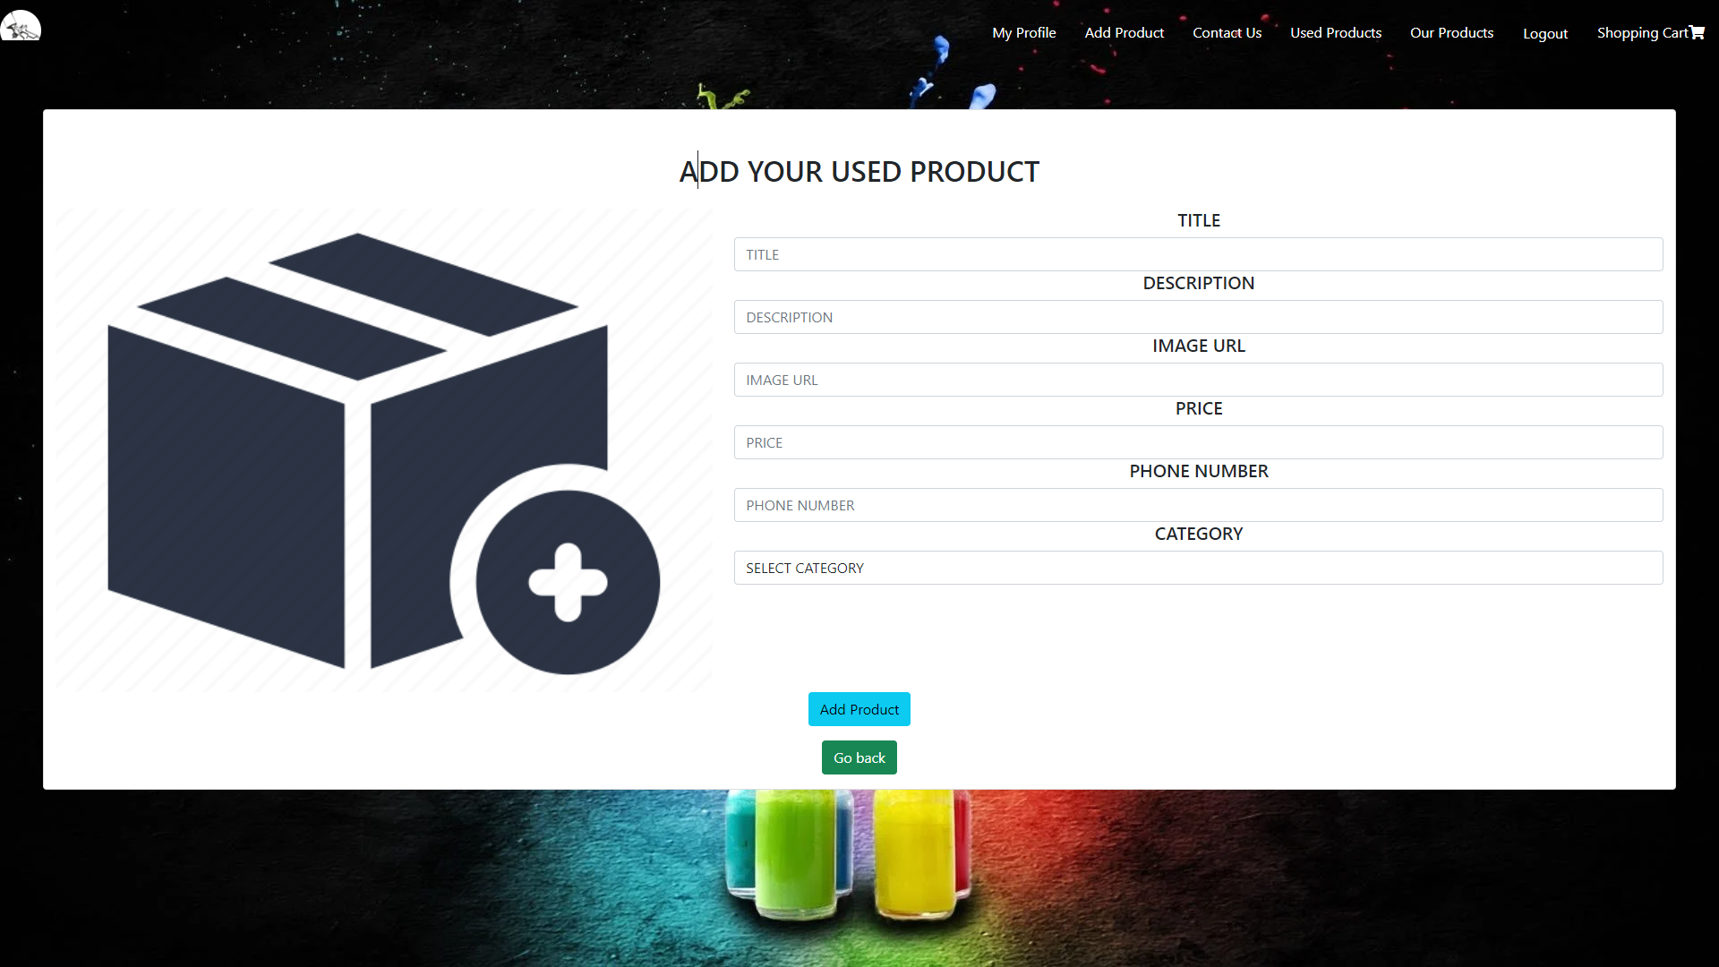

If you enter invalid data alert messages appear.

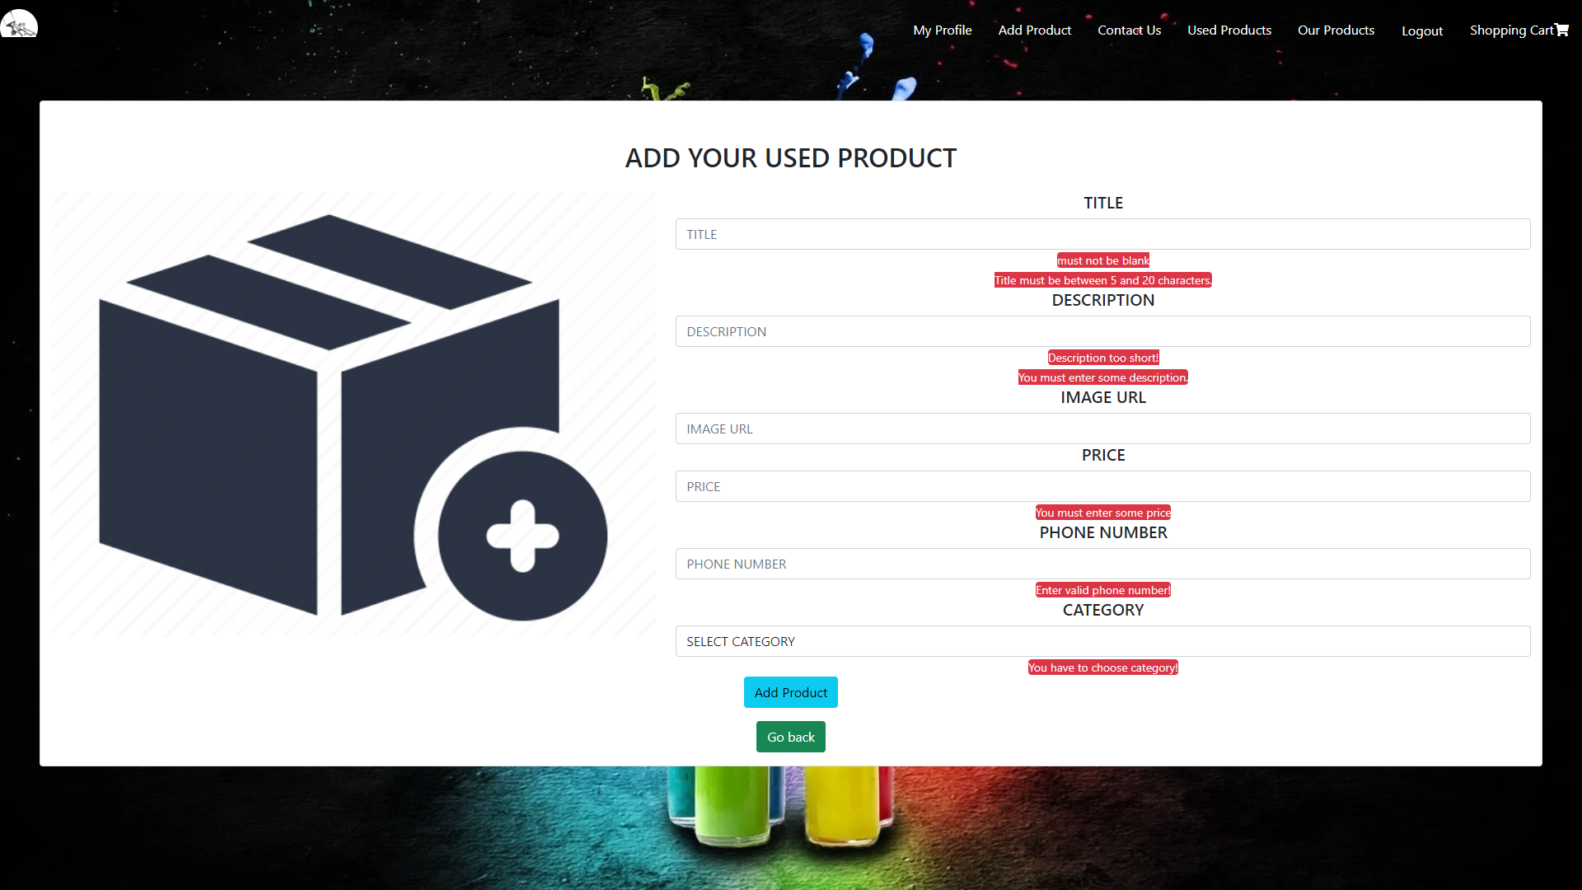

When user is the creator of a product edit and delete option is available.

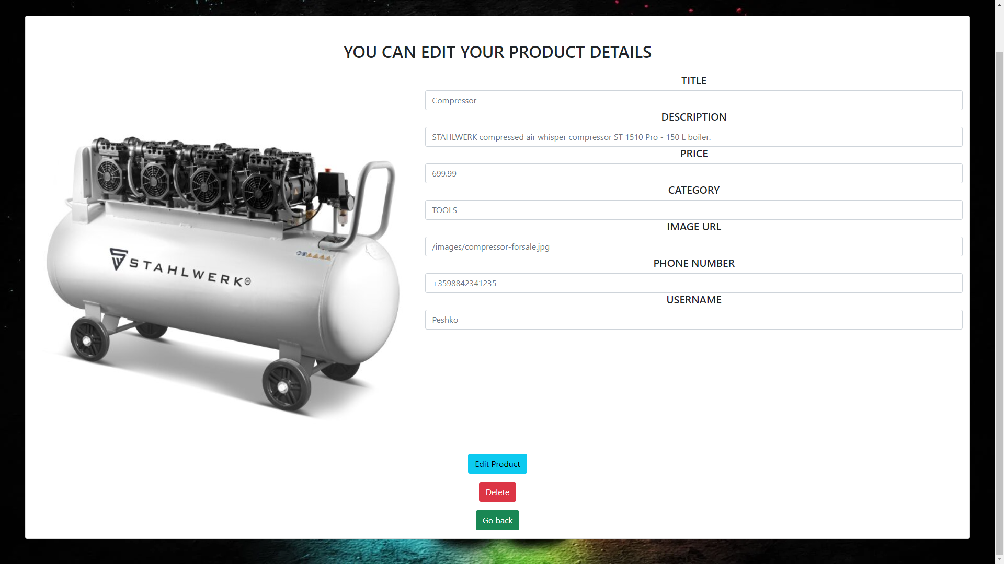

Admin cannot edit other users products but has the option to delete it.

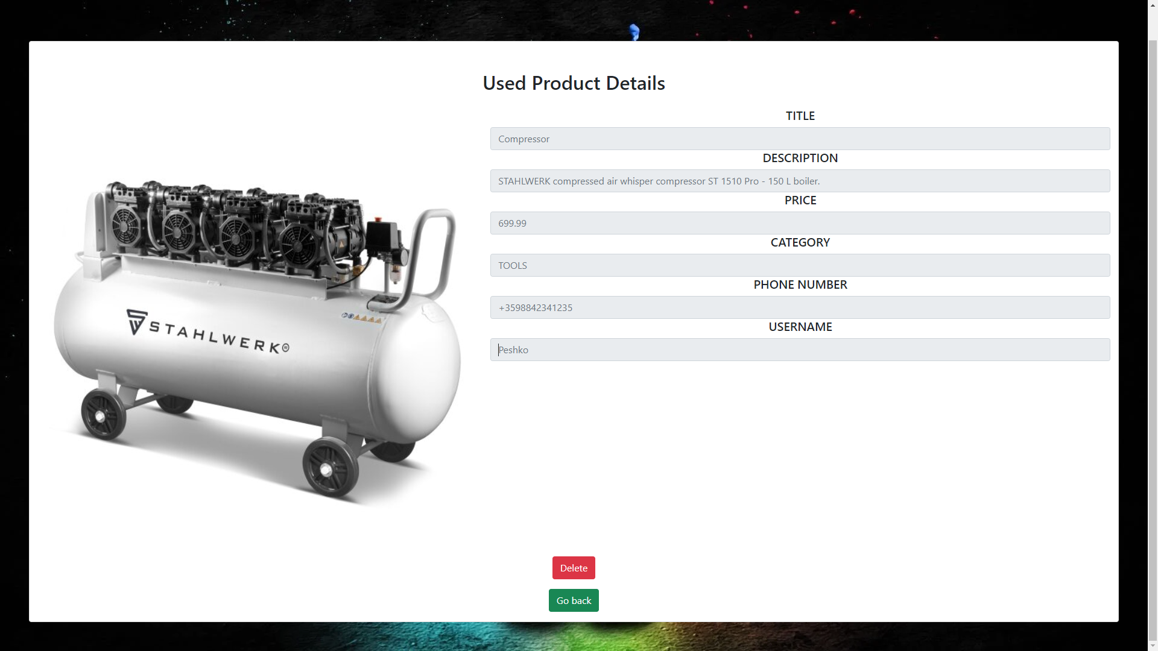

Admin panel page

Admin has four options:

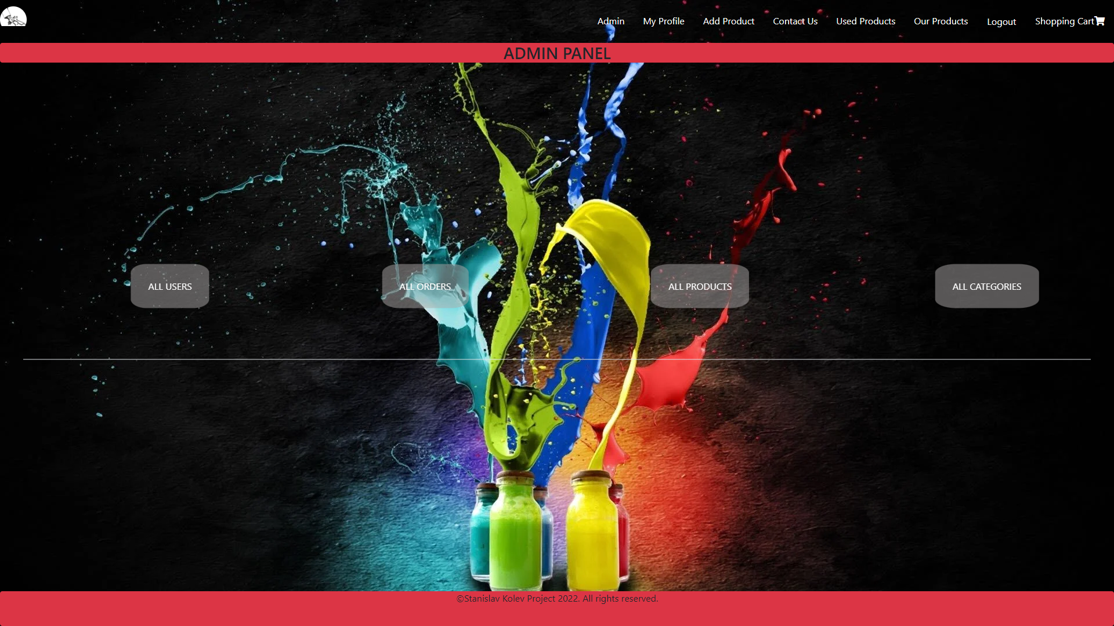

1. All users page

See all registered. Admin can delete user. Deactivate or give admin rights to other users. Also all users purchase amounts are visible.

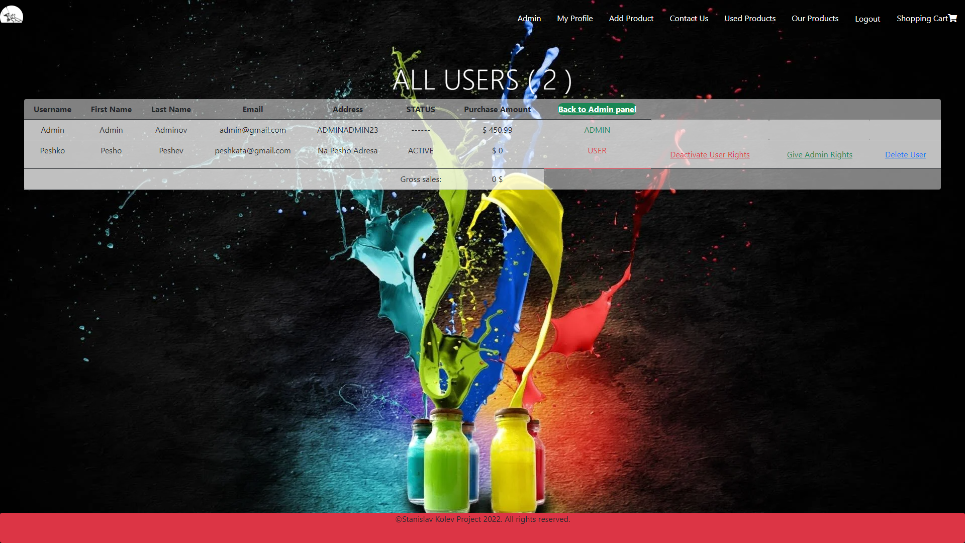

1. All orders page

Admin can remove orders or check order details.

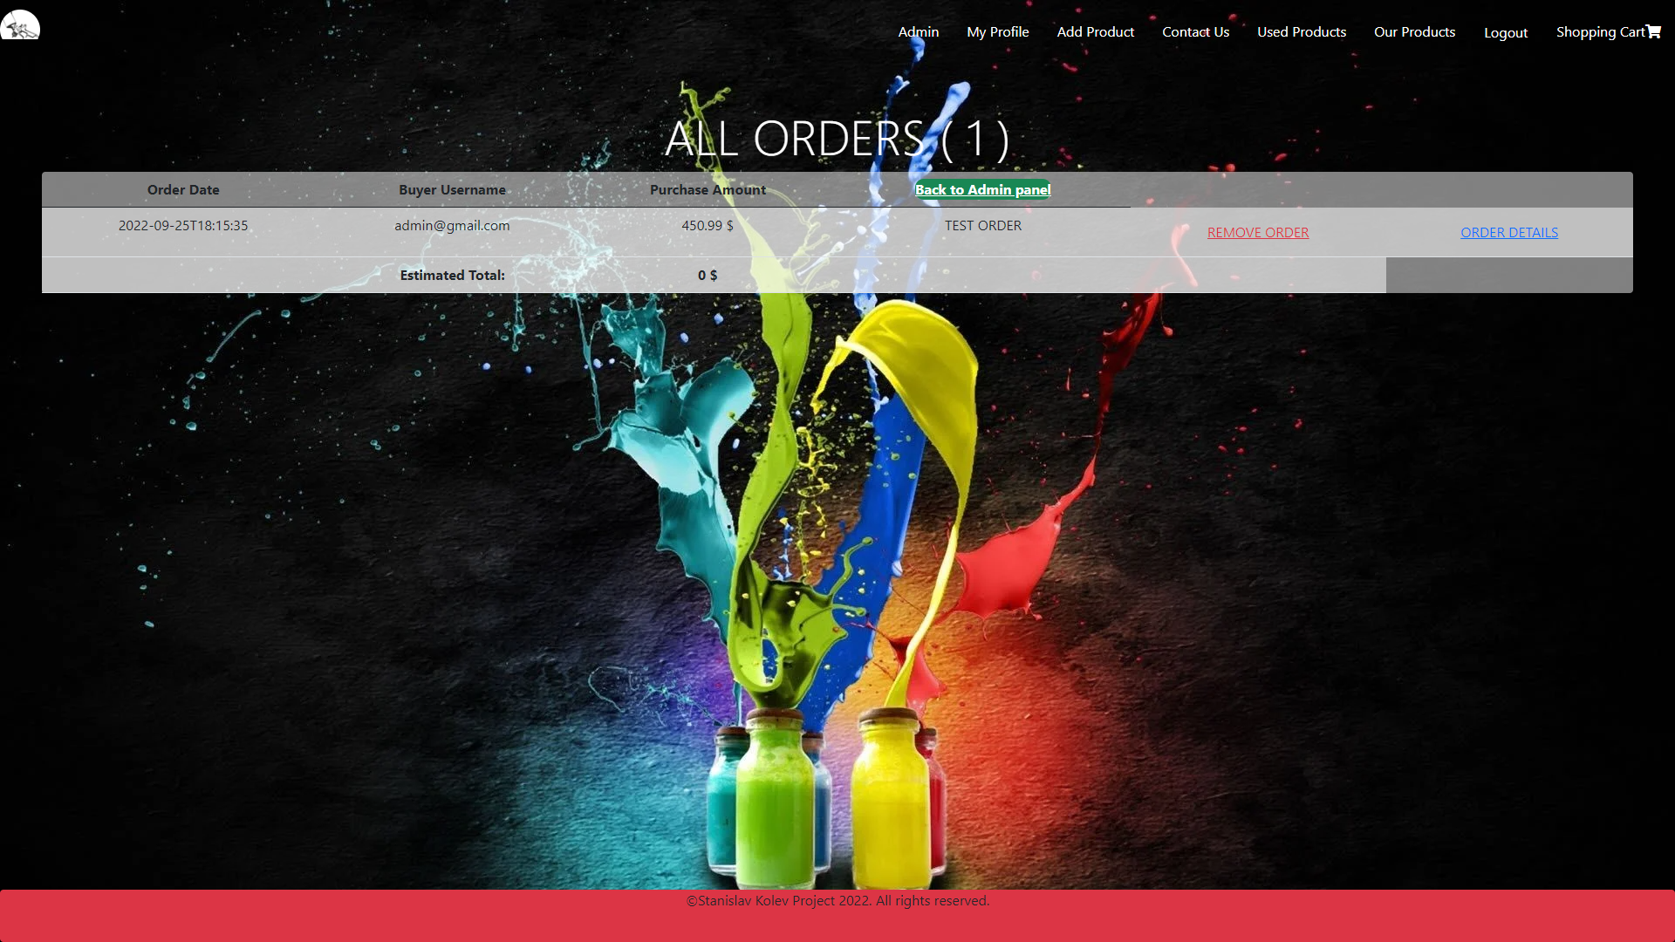

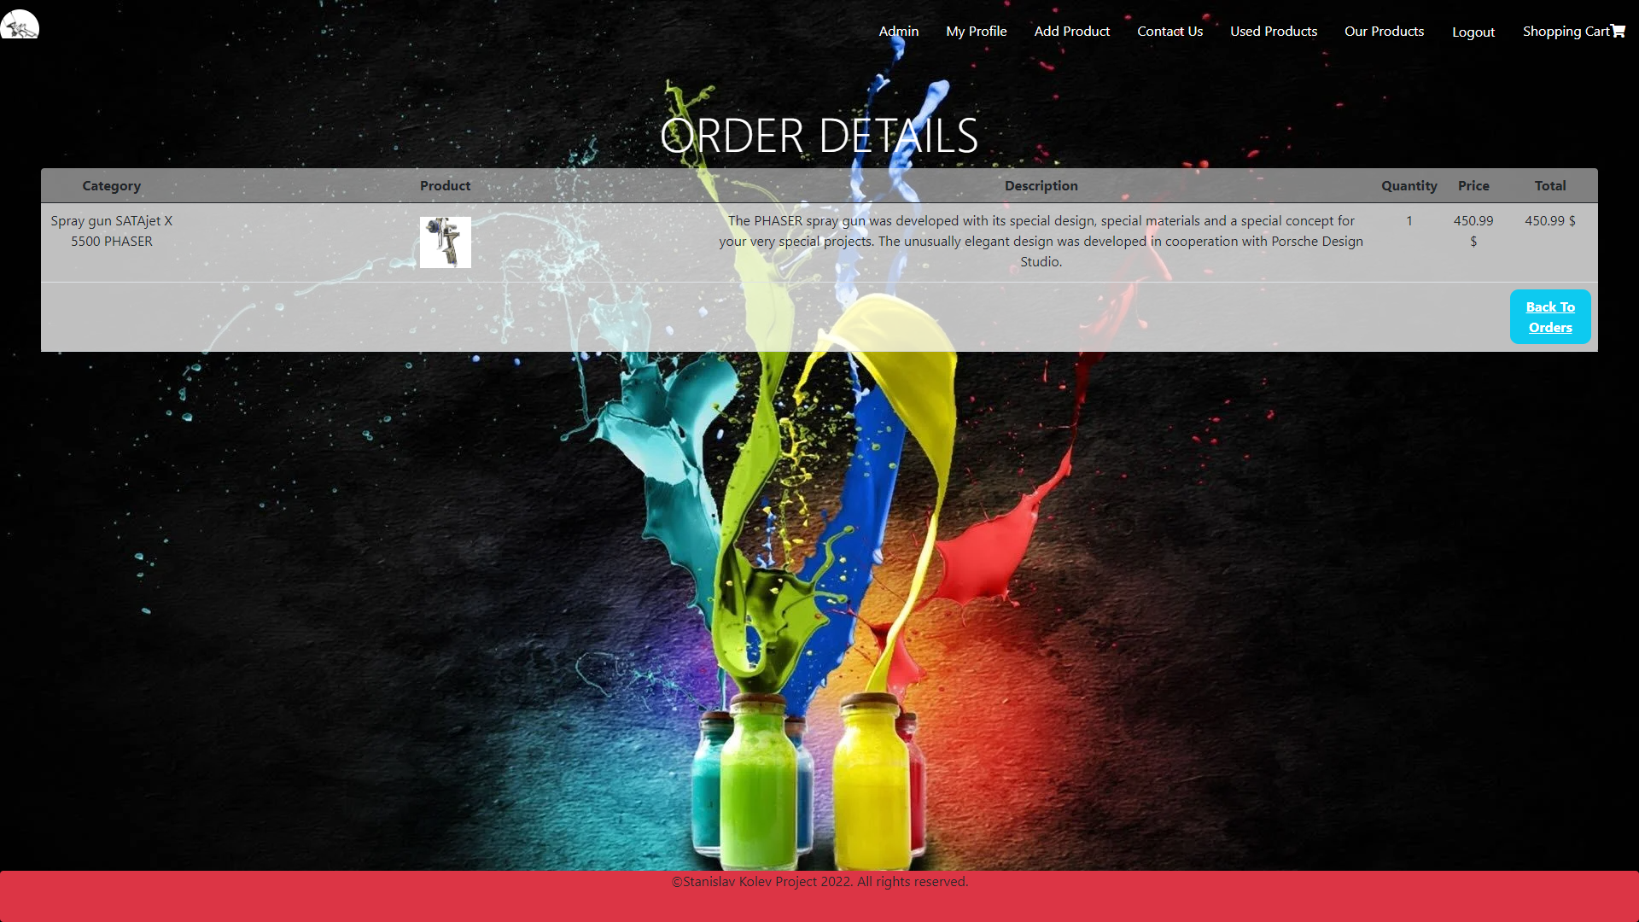

1. All products page

See all products with description, price and category. There are few options.

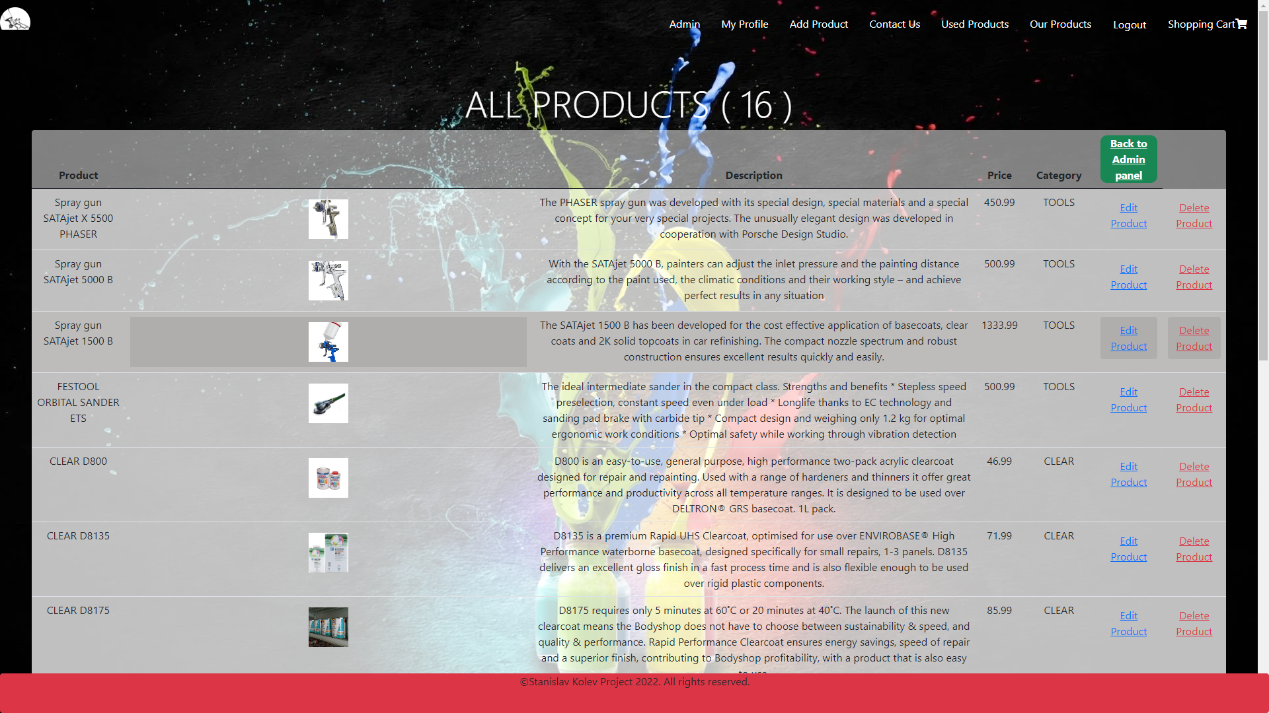

Admin can edit product.

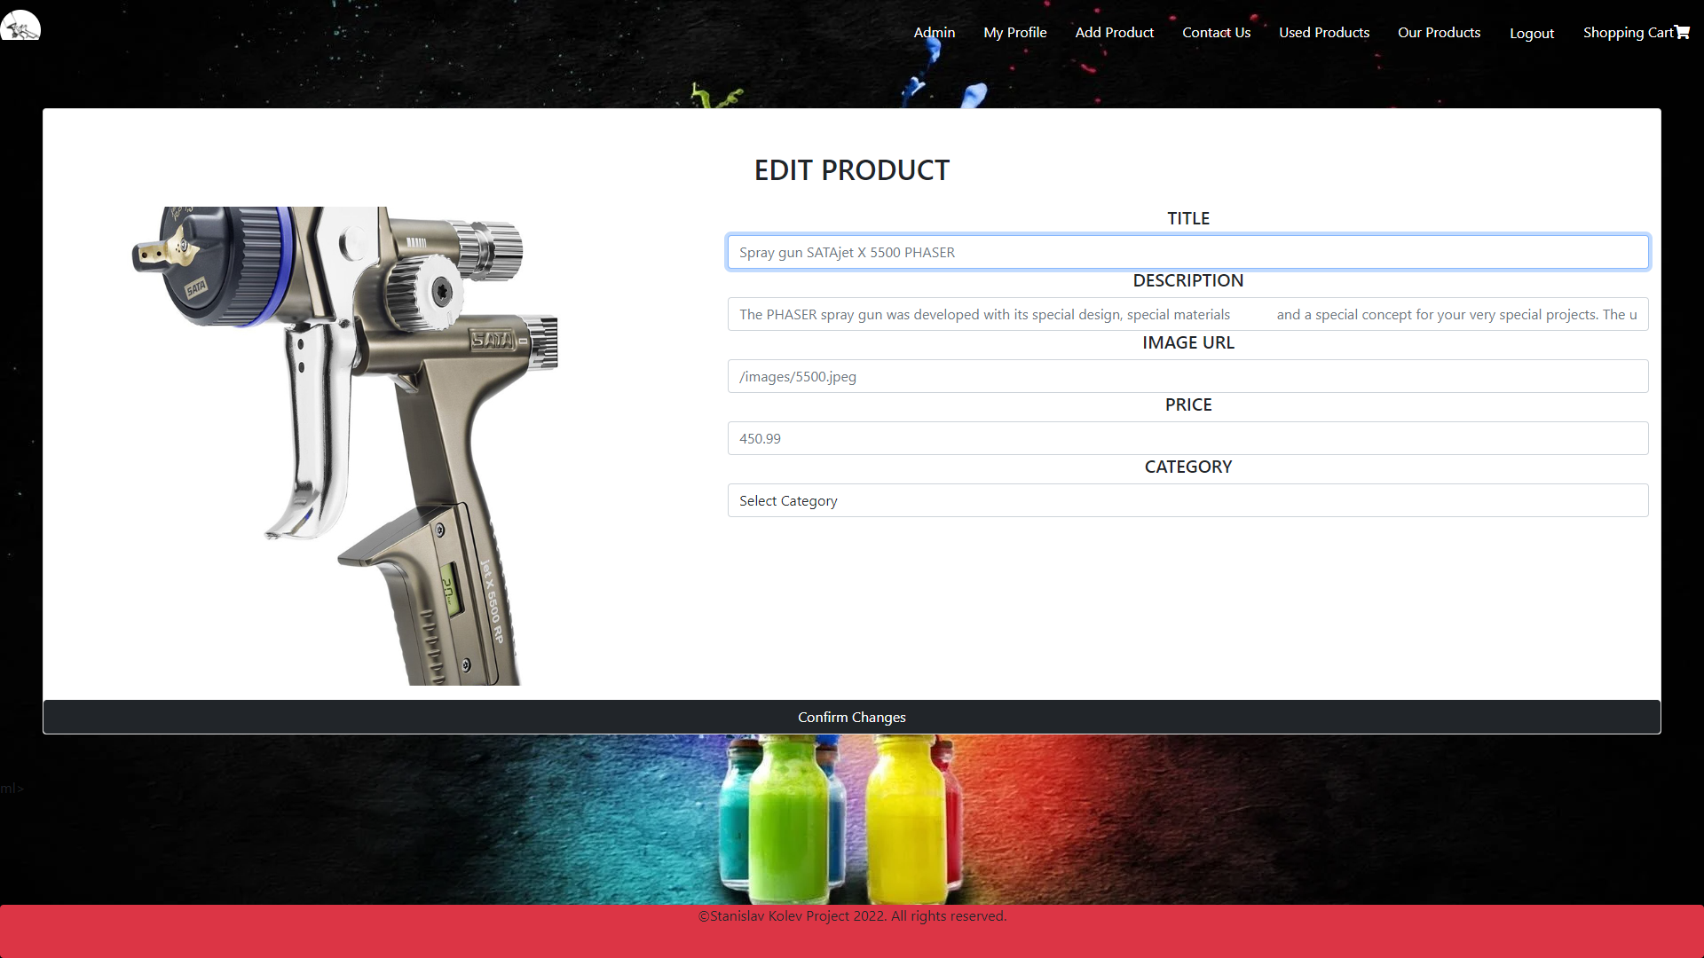

Also can add new products.

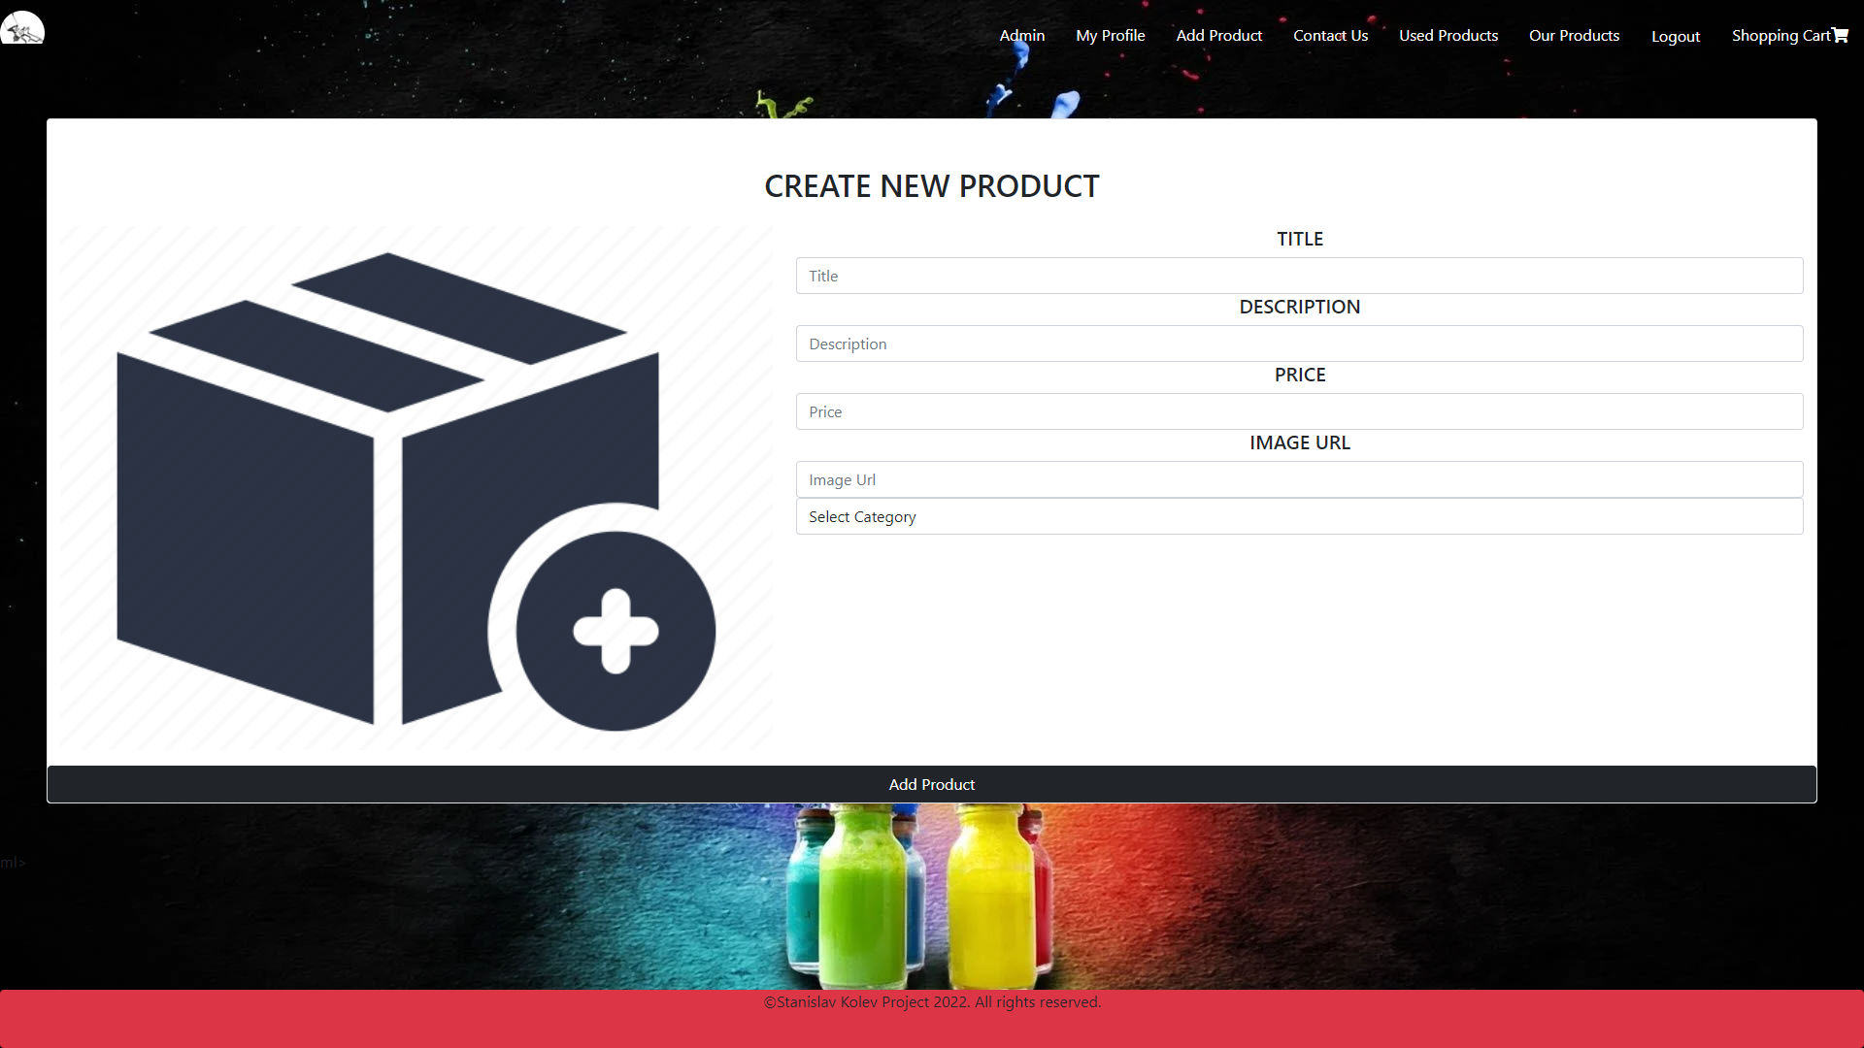

If invalid data is enter alert messages appear.

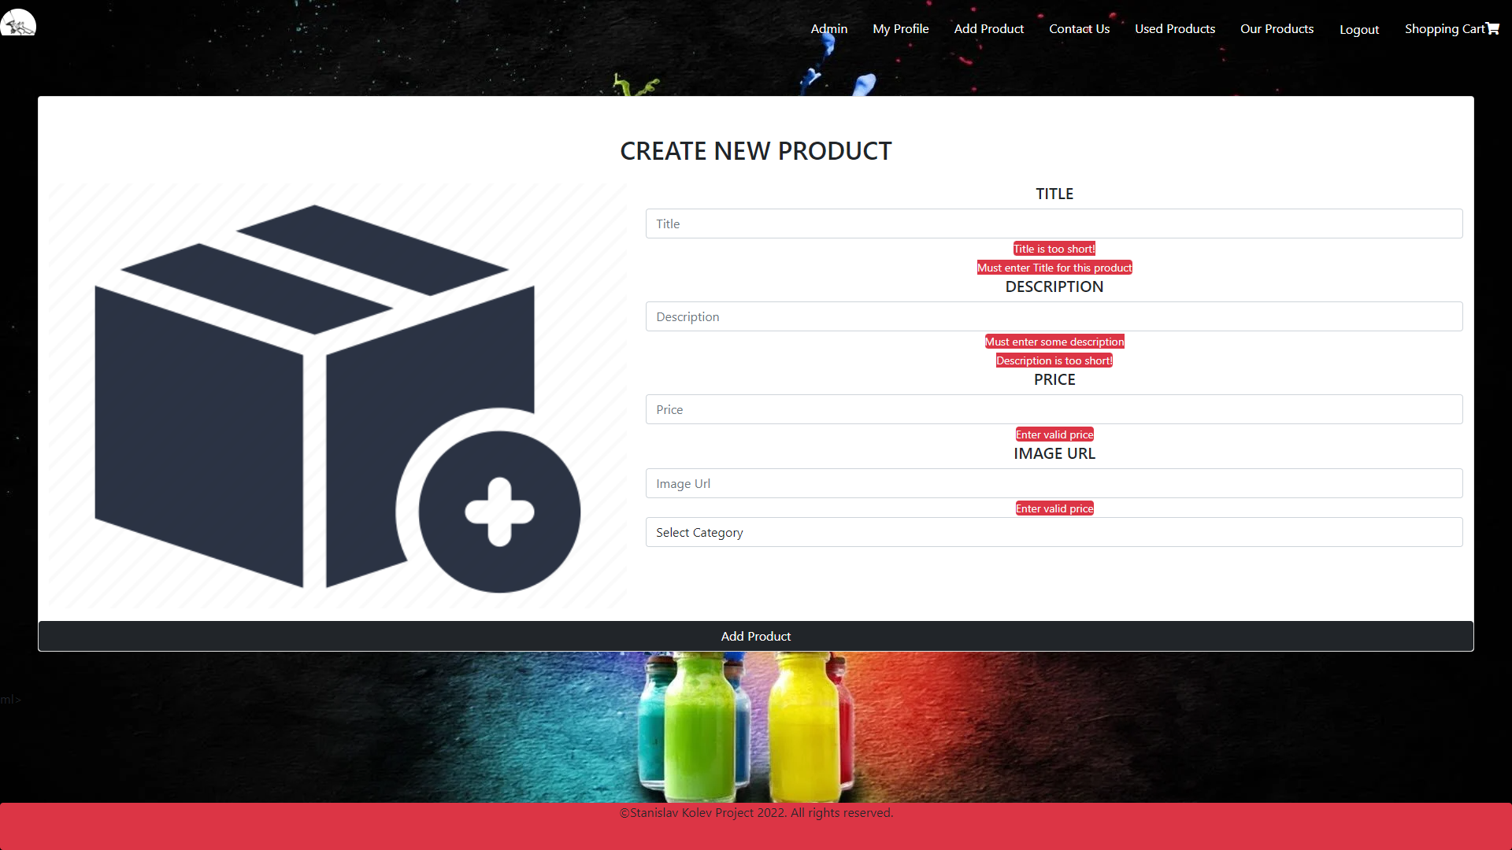

All categories page. Admin can edit or delete category. If category is deleted all

products from this category are no longer available.

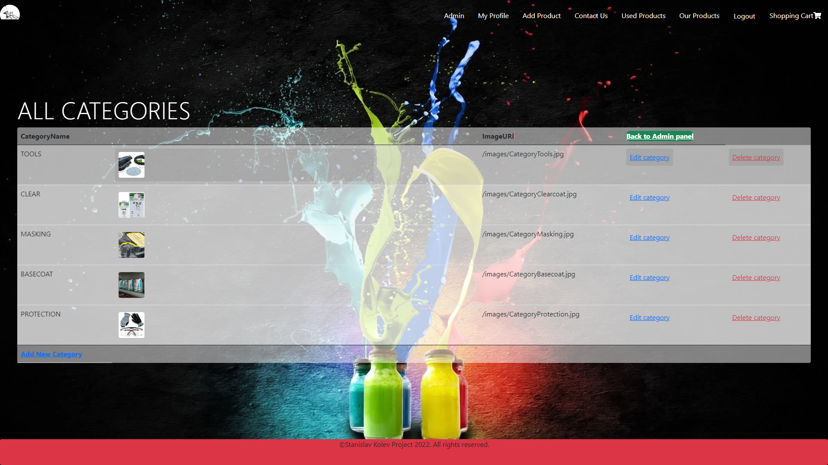

Admin can also add new categories.

